Week 9: Device Features and Sensors

Introduction

During Week 9, the development of the Parents Link mobile application focused on learning how Android applications interact with smartphone hardware. The class covered device features such as the camera, GPS, and sensors, as well as the permissions required before an application can access these resources. These concepts are important because they make mobile applications more interactive, useful, and user-friendly.

Activities Carried Out

This week, I studied the different hardware features available on Android devices and evaluated how they can be incorporated into the Parents Link application. I learned how applications communicate with the device camera, GPS, and other sensors through Android APIs. I also explored the concept of runtime permissions, which require users to grant permission before an application can access sensitive features such as the camera or location services. This knowledge is essential in ensuring that the application respects user privacy while providing useful functionality.
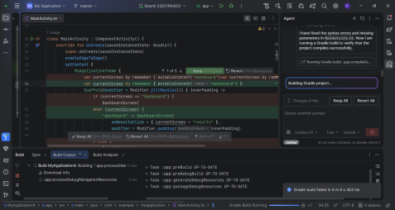
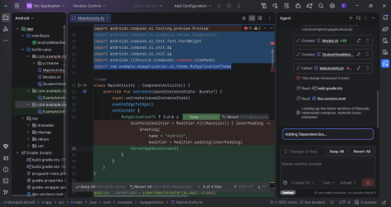

I further analyzed how these features can improve the Parents Link application. The camera can be used to allow parents and teachers to upload profile pictures, attach images of school activities, or share important documents. GPS functionality can help users identify the location of the school during meetings, events, or emergencies, while future integration with Google Maps can provide accurate navigation. These planned features will improve communication between parents and the school.

Another area of focus was understanding Android development best practices. I learned the importance of requesting only the permissions that are necessary, handling denied permissions gracefully, protecting user privacy, and minimizing battery consumption when using location services. These practices will help ensure that the Parents Link application remains secure, efficient, and reliable.

Skills Acquired

By the end of the week, I had gained a better understanding of Android device feature integration and how these features can be applied in a real-world application. I improved my knowledge of runtime permissions, camera integration, GPS functionality, and Android development practices. I also learned how proper planning before implementation makes it easier to integrate advanced features into an application.

Challenges Encountered

One of the main challenges was understanding how Android manages runtime permissions and how they should be implemented correctly. I also found it challenging to understand how GPS retrieves location data accurately and how camera functionality can be integrated with Firebase storage. Since these features involve multiple Android components, they required additional research and practice.

Solutions

To overcome these challenges, I referred to the class notes and Android documentation to understand the implementation process. I also reviewed examples of camera and GPS integration in Android Studio and planned how these features would fit into the Parents Link application. This preparation has made it easier to proceed with implementation in future development stages.

Conclusion

Week 9 was an important milestone in the development of the Parents Link mobile application. Although the camera and GPS features have not yet been fully implemented, I successfully understood their purpose, requirements, and how they can improve the application. The knowledge gained during this week will guide the next phase of development, where these device features will be integrated to create a more practical, interactive, and user-friendly application for parents, teachers, and school administrators.

